# **Chapter 3: Requirement Analysis**

In this chapter we will define all the requirements of proposed system that include functional and non-functional requirements. We will also discuss about use cases of the system and see how our system will respond to various use cases.

# **3.1.** **Functional Requirements**

For our system to work and facilitate the user number of functional requirements have been are needed. These functional requirements also be presumed as interface requirements as they are all but interface.

* The system will authenticate the user through login functionality.
* The system will display the previous projects.
* The system will display the member list to project admin.
* The system will allow project admin to create new projects .
* The system will allow project admin to perform edit delete operations on created projects.
* The system will allow to perform edit delete operation on member.
* System allow admin to assign project to different members.
* The system will allow member to test the feasibility study.
* The system will allow member to add cost.
* The system will allow member to add risk.
* The system will allow member to add Integration.
* The system will allow member to add stakeholder.
* The system will allow member to add module.
* The system will allow member to add procurement.
* The system will allow member to add Resources.
* The system will allow member to view proposal.
* The system will allow member to chat with its teammate and project admin.
* Member recieve notification if teammate or project admin send message.

# **3.1.** **Non-Functional Requirements**

* The system should be able to handle the concurrent requests from different users.
* The system should provide confidentiality for user data.
* The system should be stable and reliable enough to handle the exceptions.
* The system should be available for 24/7 of the time to handle the concurrent request of the users.
* The system should permit only authorize users to ensure its security.
* The system should be efficient enough to handle the concurrent request to the user.
* Interface and the system itself should be user friendly so that the customer will feel it easy to use.
* The system will authenticate the user by verifying the credentials to database.

# **Use Case Model**

In the Unified Modeling Language (UML), a use case diagram can summarize the details of your system's users (also known as actors) and their interactions with the system. Following are the use cases of the Product Lifecycle Management

**3.3.1 Use Case Diagram:**

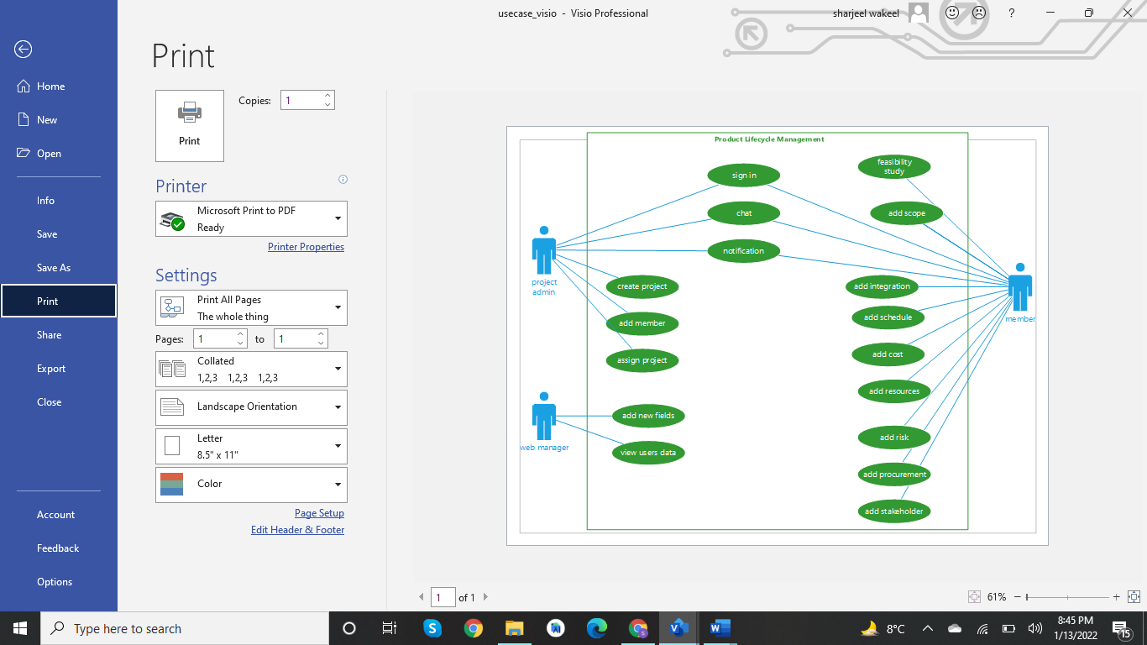

·

**Actors Description:**

**We have four types of actors.**

**Project manager:**

Project manager is a primary actor which directly interacts with a website. He can add projects ,add users, assign projects and is also able to edit and delete project, users.

**User:**

User is also the primary actor .He can view assigned projects and is able to accept or reject projects and perform some operation on the project.

**Web Manager:**

Web manager authenticates himself. He can add new fields and manage the website.

**Database:**

Database stores all the information and data fetched through it as well.

**Use Case Description**

|  |  |
| --- | --- |
| **User Case Name:** | ID-01 |
| **Use Case Name:** | Sign in |
| **Actors:** | Project admin, user, web manager |
| **Description:** | User will provide its credentials and be authenticated by the system through the database. |
| **Trigger:** | When the user clicks on the sign in button |
| **Preconditions:** | User should be sign in page |
| **Postconditions:** | User will login successfully and redirect to home page |
| **Normal Flow:** | 1.user enter email and password.  2.system validates the email and password.  3.system match email and password through database  4.system redirect to home page |
| **Alternative Flows:** | 2a. Error show please fill required fields  3a.Error show please enter valid email and password  4a.don’t redirect to the home page |
| **Exceptions:** | None |
| **Special Requirements:** | None |
| **Assumptions:** | None |
| **Notes and Issues:** | None |

**Table 3.1: Sign in**

|  |  |
| --- | --- |
| **User Case ID:** | ID-02 |
| **Use Case Name:** | Create Project |
| **Actors:** | Project admin |
| **Description:** | Project admin clicks on create project option and fills the field after the validation form is submitted and gets a successful message. |
| **Trigger:** | When the admin clicks on create project. |
| **Preconditions:** | Admin should be on the home page. |
| **Postconditions:** | Fill the form and submit an admin get success message. |
| **Normal Flow:** | 1.click on the add project option.  2.fill all fields.  3.validate all fields.  4.store in the database.  5.get a success message. |
| **Alternative Flows:** | 3a.Error show please fill the required field. |
| **Exceptions:** | None |
| **Special Requirements:** | None |
| **Assumptions:** | None |

**Table 3.2: Create Project**

|  |  |
| --- | --- |
| **Use Case ID:** | ID-03 |
| **Use Case Name:** | Add User |
| **Actors:** | Project admin |
| **Descriptions:** | Project admin clicks on add user option and fills the field after the validation form is submitted and gets a successful message. |
| **Trigger:** | When the admin clicks on add user. |
| **Preconditions:** | Admin should be on the home page. |
| **Postconditions:** | Fill the form and submit an admin get success message. |
| **Normal Flow:** | 1.click on the add project option.  2.fill all fields.  3.validate all fields.  4.store in the database.  5.get a success message. |
| **Alternative Flows:** | 3a.Error show please fill the required field. |
| **Exceptions:** | None |
| **Special Requirements:** | None |
| **Assumption** | None |

**Table 3.3: Add User**

|  |  |
| --- | --- |
| **Use Case ID:** | ID-04 |
| **Use Case Name:** | View Projects |
| **Actors:** | Project Admin |
| **Descriptions:** | Project admin click on view project and view projects |
| **Trigger:** | When a user clicks view project. |
| **Preconditions:** | Admin should be on the home page. |
| **Postconditions:** | View all projects with project id and project title with little description. |
| **Normal Flow:** | 1.click on the view project.  2.View all projects project id and project title with little description. |
| **Alternative Flows:** | None |
| **Exceptions:** | None |
| **Special Requirements:** | None |
| **Assumption** | None |

**Table 3.3: View Projects**

|  |  |
| --- | --- |
| **Use Case ID:** | ID-05 |
| **Use Case Name:** | View User |
| **Actors:** | Project Admin |
| **Descriptions:** | Project admin click on view users and view users. |
| **Trigger:** | When a user clicks view user. |
| **Preconditions:** | Admin should be on the home page. |
| **Postconditions:** | View all user with user id and user name with designation. |
| **Normal Flow:** | 1.click on view user.  2.View all user with user id and user name with designation. |
| **Alternative Flows:** | None |
| **Exceptions:** | None |
| **Special Requirements:** | None |
| **Assumption** | None |

**Table 3.3: View Users**

|  |  |
| --- | --- |
| **Use Case ID:** | ID-06 |
| **Use Case Name:** | Assign Project |
| **Actors:** | Project Admin |
| **Descriptions:** | Admin click on assign button then fill fields and submit get success message |
| **Trigger:** | When a user clicks the assign button. |
| **Preconditions:** | Admin should be on the view profile page. |
| **Postconditions:** | Admin fill fields press the assign button get success message |
| **Normal Flow:** | 1.click on the assign button.  2.fill the form.  3.Validate form field  4.store in database  5.system gives a success message |
| **Alternative Flows:** | 3a.Error show please fill required fields |
| **Exceptions:** | None |
| **Special Requirements:** | None |
| **Assumption** | None |

**Table 3.3: Assign Project**

|  |  |
| --- | --- |
| **Use Case ID:** | ID-07 |
| **Use Case Name:** | Notification |
| **Actors:** | Project Admin, User |
| **Descriptions:** | Users get notification through the system if someone performs some activity on a given project. |
| **Trigger:** | When user clicks on notification |
| **Preconditions:** | User should be on the view profile page. |
| **Postconditions:** | User check notifications. |
| **Normal Flow:** | 1.click on notification.  2.check notifications. |
| **Alternative Flows:** | None |
| **Exceptions:** | None |
| **Special Requirements:** | None |
| **Assumption** | None |

**Table 3.3: Notification**

|  |  |
| --- | --- |
| **Use Case ID:** | ID-08 |
| **Use Case Name:** | Chat |
| **Actors:** | Project Admin, User |
| **Descriptions:** | Users get notification through the system if someone texts. |
| **Trigger:** | When a user clicks the message button. |
| **Preconditions:** | User should be on the home page. |
| **Postconditions:** | See who text him and answer him |
| **Normal Flow:** | 1.get alert  2.click on the message button.  3.see who sent a message to him.  4.answer him.  5.store answer in the database. |
| **Alternative Flows:** | None |
| **Exceptions:** | None |
| **Special Requirements:** | None |
| **Assumption** | None |

**Table 3.3: Chat**

|  |  |
| --- | --- |
| **Use Case ID:** | ID-09 |
| **Use Case Name:** | Feasibility study |
| **Actors:** | User |
| **Descriptions:** | User click on feasibility option fill field. |
| **Trigger:** | When a user clicks the feasibility option. |
| **Preconditions:** | User should be on the home page. |
| **Post conditions:** | User fills the field and clicks the submit button to get success message. |
| **Normal Flow:** | 1.click on the feasibility button.  2.fill the form.  3.validate form.  4.store in the database.  5.get a success message. |
| **Alternative Flows:** | 3a.Errro show please fill required field. |
| **Exceptions:** | None |
| **Special Requirements:** | None |
| **Assumption** | None |

**Table 3.3: Feasibility study**

|  |  |
| --- | --- |
| **Use Case ID:** | ID-010 |
| **Use Case Name:** | Add Scope |
| **Actors:** | User |
| **Descriptions:** | User clicks on the add scope option to fill field. |
| **Trigger:** | When a user clicks the add scope option. |
| **Preconditions:** | User should be on the home page. |
| **Postconditions:** | User fills the field and clicks the submit button to get success message. |
| **Normal Flow:** | 1.click on the scope button.  2.fill the form.  3.validate form.  4.store in the database.  5.get a success message. |
| **Alternative Flows:** | 3a.Errro show please fill required field. |
| **Exceptions:** | None |
| **Special Requirements:** | None |
| **Assumption** | None |

**Table 3.3: Add Study**

|  |  |
| --- | --- |
| **Use Case ID:** | ID-11 |
| **Use Case Name:** | Add Risk |
| **Actors:** | User |
| **Descriptions:** | User click on add risk option to fill field. |
| **Trigger:** | When a user clicks the feasibility option. |
| **Preconditions:** | User should be on the home page. |
| **Postconditions:** | User fills the field and clicks the submit button to get success message. |
| **Normal Flow:** | 1.click on the risk button.  2.fill the form.  3.validate form.  4.store in the database.  5.get a success message. |
| **Alternative Flows:** | 3a.Errro show please fill required field. |
| **Exceptions:** | None |
| **Special Requirements:** | None |
| **Assumption** | None |

**Table 3.3: Add Risk**

|  |  |
| --- | --- |
| **Use Case ID:** | ID-12 |
| **Use Case Name:** | Add schedule |
| **Actors:** | User |
| **Descriptions:** | User click on schedule option to fill the fields. |
| **Trigger:** | When a user clicks the add schedule option. |
| **Preconditions:** | User should be on the home page. |
| **Postconditions:** | User fills the field and clicks the submit button to get success message. |
| **Normal Flow:** | 1.click on the schedule button.  2.fill the form.  3.validate form.  4.store in the database.  5.get a success message. |
| **Alternative Flows:** | 3a.Error show please fill required field. |
| **Exceptions:** | None |
| **Special Requirements:** | None |
| **Assumption** | None |

|  |  |
| --- | --- |
| **User Case Name:** | ID-13 |
| **Use Case Name:** | Add cost |
| **Actors:** | User |
| **Description:** | User click on the Add cost button to fill fields. |
| **Trigger:** | When the user clicks on the add cost button. |
| **Preconditions:** | User should be on home page. |
| **Postconditions:** | User fills the field and clicks the submit button to get success message |
| **Normal Flow:** | 1.click on the cost button.  2.fill the form.  3.validate form.  4.store in the database.  5.get a success message |
| **Alternative Flows:** | 3a. Error show please fill required fields |
| **Exceptions:** | None |
| **Special Requirements:** | None |
| **Assumptions:** | None |
| **Notes and Issues:** | None |

**Table 3.3: Add Cost**

|  |  |
| --- | --- |
| **User Case Name:** | ID-14 |
| **Use Case Name:** | Add stakeholder |
| **Actors:** | User |
| **Description:** | User click on the stakeholder button to fill fields. |
| **Trigger:** | When the user clicks on the stakeholder button. |
| **Preconditions:** | User should be on home page. |
| **Postconditions:** | User fills the field and clicks the submit button to get success message |
| **Normal Flow:** | 1.click on the stakeholder button.  2.fill the form.  3.validate form.  4.store in the database.  5.get a success message |
| **Alternative Flows:** | 3a. Error show please fill required fields |
| **Exceptions:** | None |
| **Special Requirements:** | None |
| **Assumptions:** | None |
| **Notes and Issues:** | None |

**Table 3.3: Stakeholder**

|  |  |
| --- | --- |
| **User Case Name:** | ID-15 |
| **Use Case Name:** | Add Integration |
| **Actors:** | User |
| **Description:** | User click on the Integration button to fill fields. |
| **Trigger:** | When the user clicks on the Integration button. |
| **Preconditions:** | User should be on home page. |
| **Postconditions:** | User fills the field and clicks the submit button to get success message |
| **Normal Flow:** | 1.click on the Integration button.  2.fill the form.  3.validate form.  4.store in the database.  5.get a success message |
| **Alternative Flows:** | 3a. Error show please fill required fields |
| **Exceptions:** | None |
| **Special Requirements:** | None |
| **Assumptions:** | None |
| **Notes and Issues:** | None |

**Table 3.3: Integration**

|  |  |
| --- | --- |
| **User Case Name:** | ID-16 |
| **Use Case Name:** | Add new field |
| **Actors:** | Web manager |
| **Description:** | User click on the add new button to fill fields. |
| **Trigger:** | When the user clicks on the add new button. |
| **Preconditions:** | User should be on home page. |
| **Postconditions:** | User fills the field and clicks the submit button to get success message |
| **Normal Flow:** | 1.click on the add new button.  2.fill the form.  3.validate form.  4.store in the database.  5.get a success message |
| **Alternative Flows:** | 3a. Error show please fill required fields |
| **Exceptions:** | None |
| **Special Requirements:** | None |
| **Assumptions:** | None |
| **Notes and Issues:** | None |

**Table 3.3: Add new field**

|  |  |
| --- | --- |
| **User Case Name:** | ID-17 |
| **Use Case Name:** | Add Procurement |
| **Actors:** | User |
| **Description:** | User click on the Procurement button to fill fields. |
| **Trigger:** | When the user clicks on the Procurement button. |
| **Preconditions:** | User should be on home page. |
| **Postconditions:** | User fills the field and clicks the submit button to get success message |
| **Normal Flow:** | 1.click on the Procurement button.  2.fill the form.  3.validate form.  4.store in the database.  5.get a success message |
| **Alternative Flows:** | 3a. Error show please fill required fields |
| **Exceptions:** | None |
| **Special Requirements:** | None |
| **Assumptions:** | None |
| **Notes and Issues:** | None |

**Table 3.3: add procurement**

# **Chapter 4: Design and Architecture**

In this chapter we will discuss the design and architecture of our system.

**4.1. System Architecture**

As system design varies from system to system, therefore user need to have the architecture view of the whole system.

Presentation tier

Interface

Business logic tier

Web server

**Data management tier**

Database server

**Fig 4.1: System Architecture**

**4.2. System Design**

Systems design is the process of defining elements of a system like components, modules, architecture and their interfaces and data for a system based on the specified requirements. The purpose of the System Design process is to provide sufficient detailed data and information about the system. Following is the system design of the Product Lifecycle Management.

**Class diagram**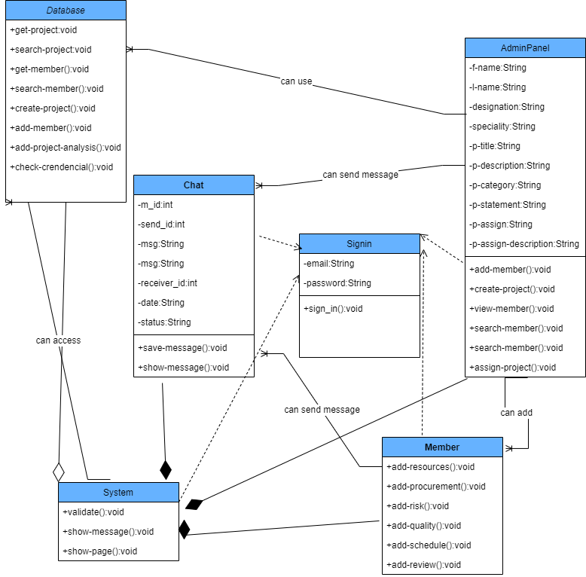

**ER Diagram:**

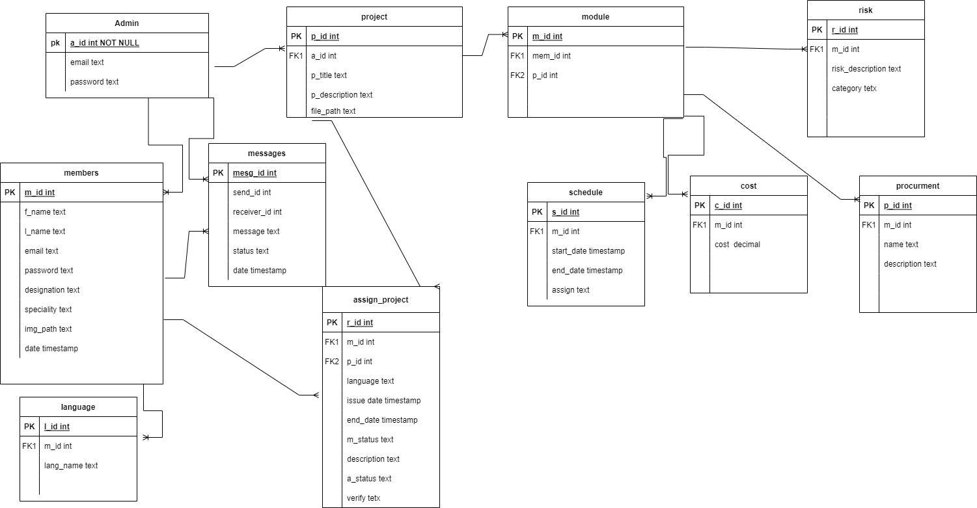

**4.3 Activity diagrams:**

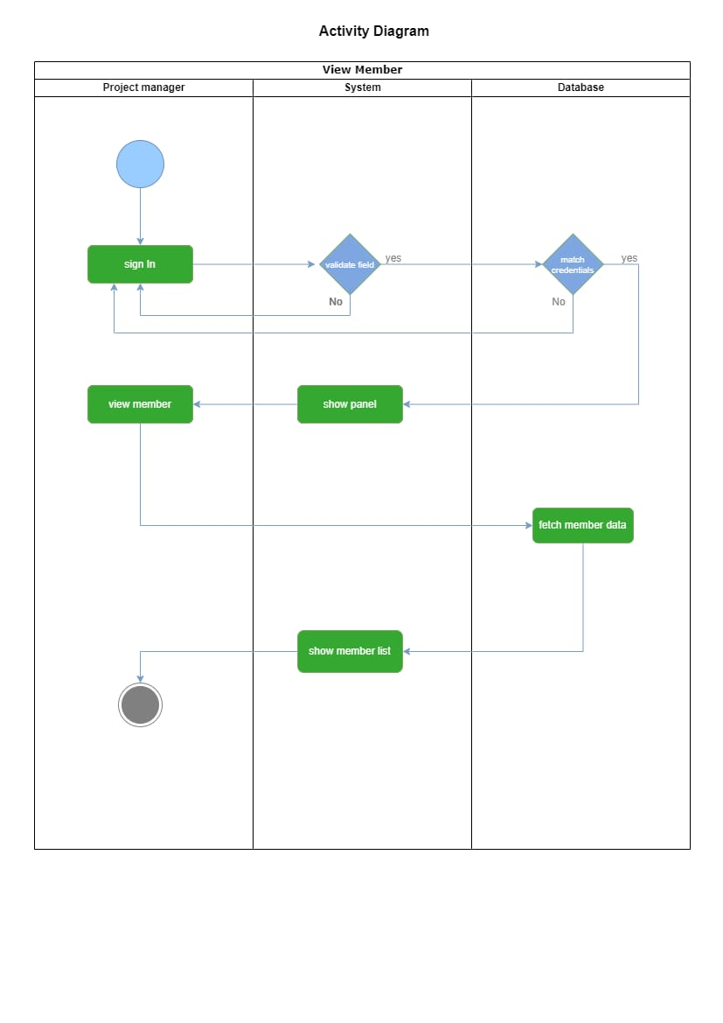

**Fig 4.3 Activity diagram for view member**

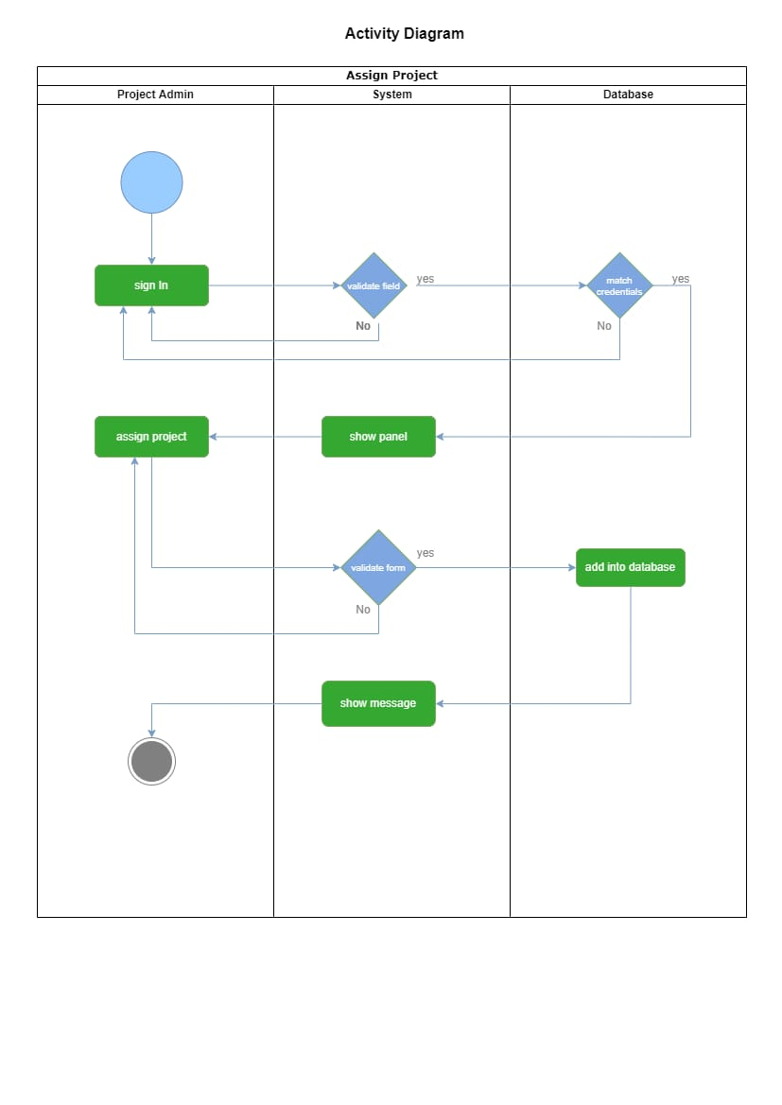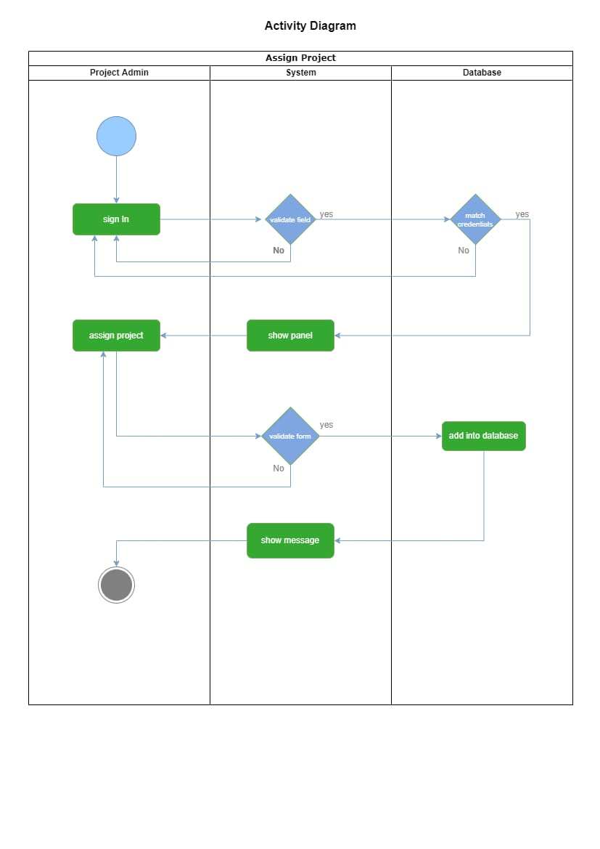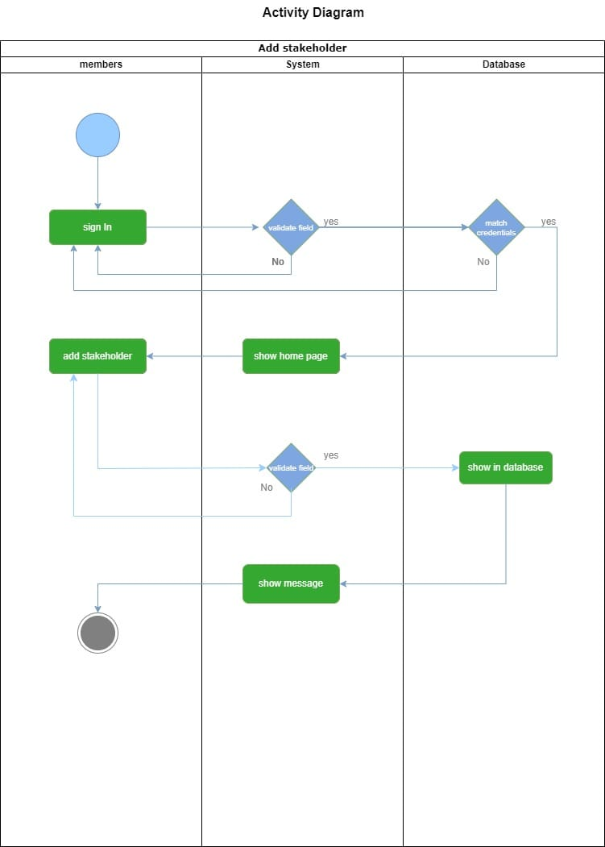

**Fig 4.4 Activity diagram for Assign project**

**Fig 4.4 Activity diagram for Assign project**

**Fig 4.5 Activity diagram for Add Stakeholder**

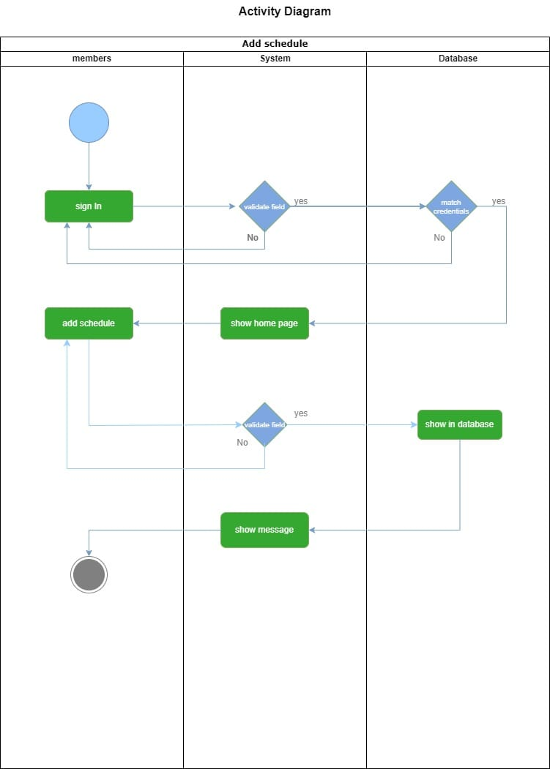

**Fig 4.6 Activity diagram for Add Schedule**

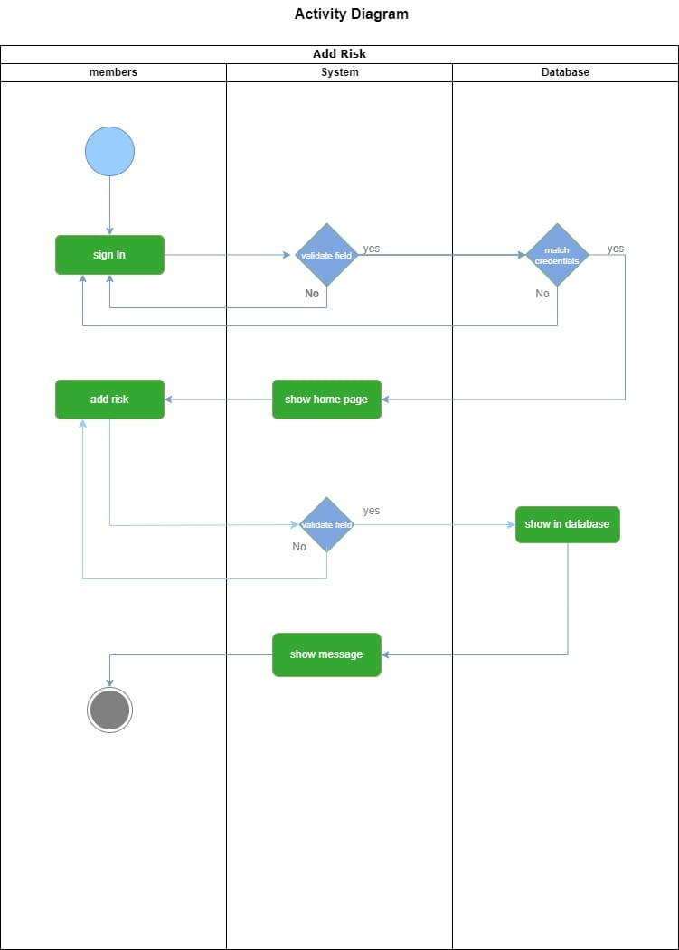

**Fig 4.7 Activity diagram for Add Risk**

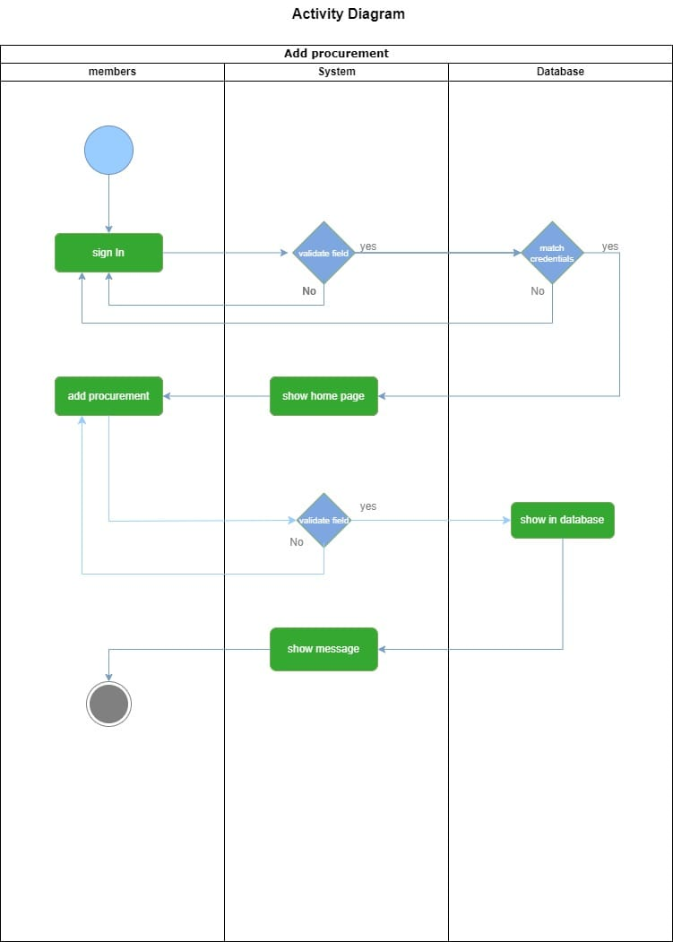

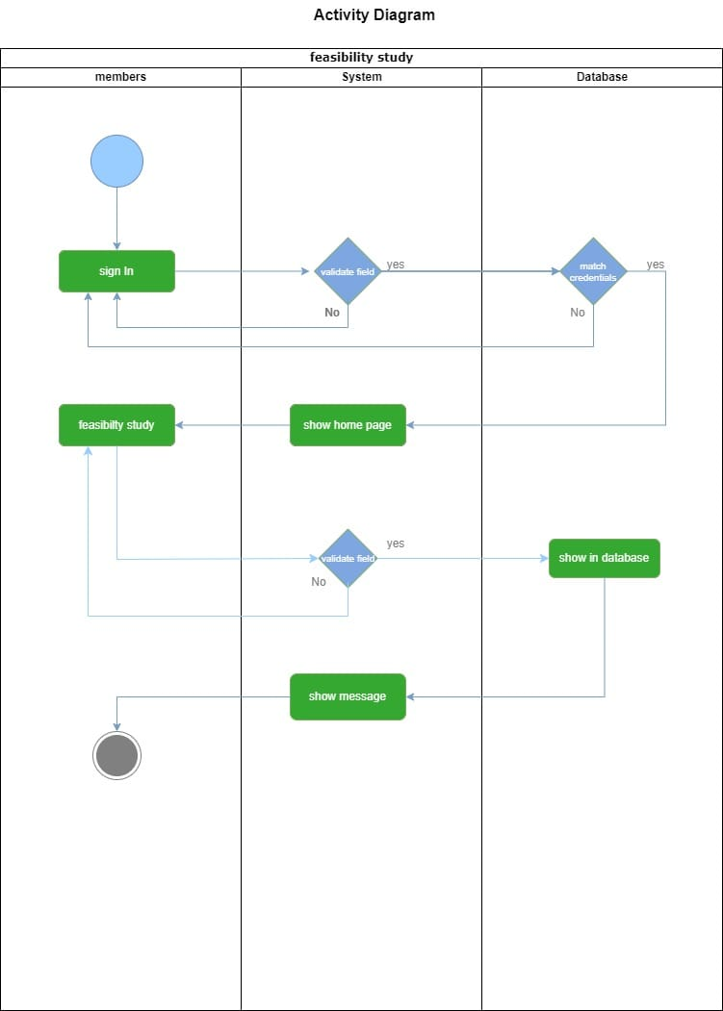

**Fig 4.9 Activity diagram for Feasibility study**

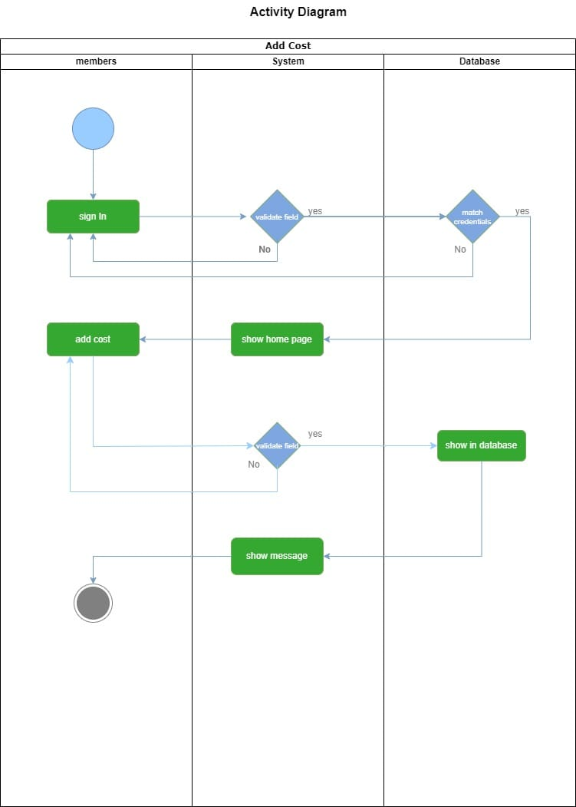

**Fig 4.10 Activity diagram for Add cost**

**5.1:Sequence Diagram:**

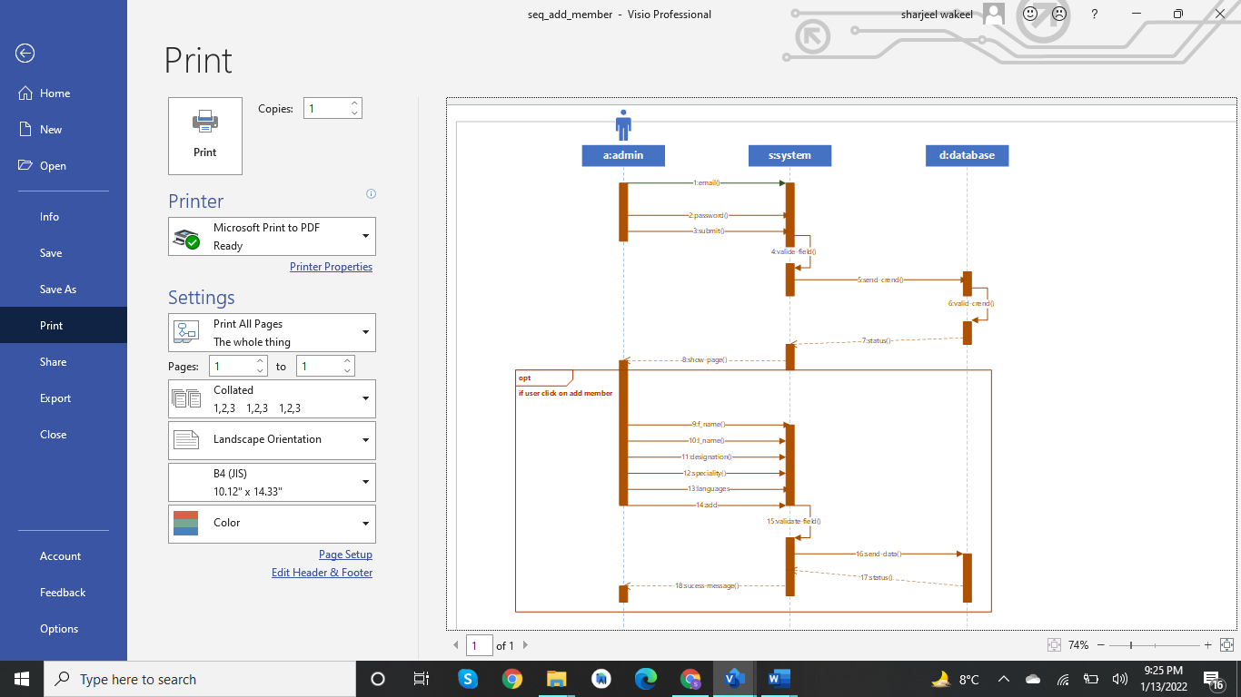

**Fig 5.1: sequence diagram for add member**

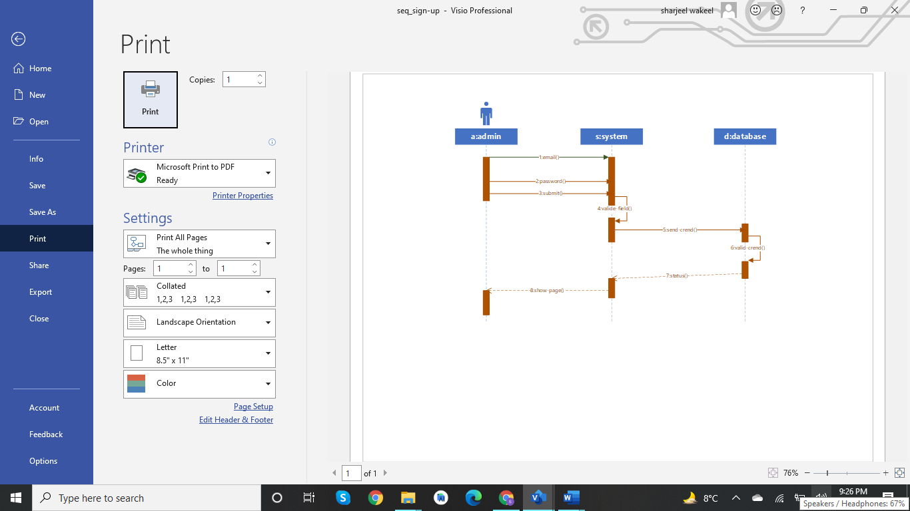

**Fig 5.2 : sequence diagram for add member**

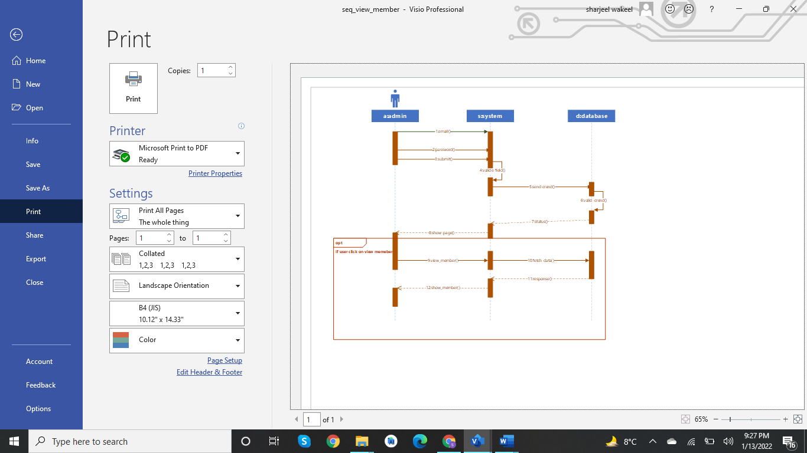

**Fig 5.3: sequence diagram for View member**

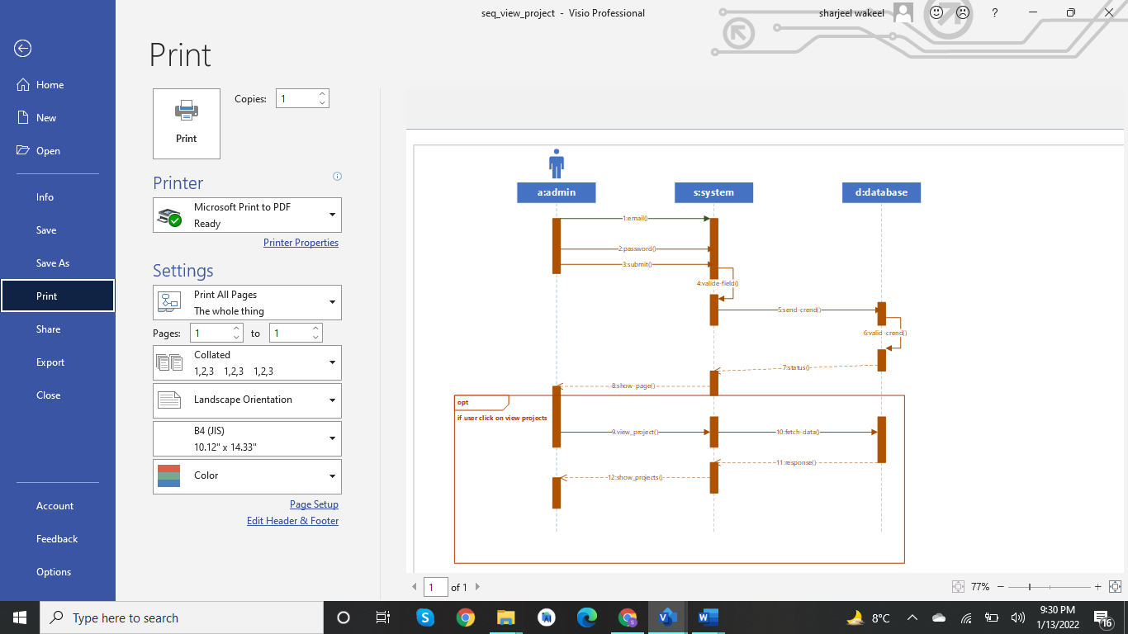

**Fig 5.4: sequence diagram for View projects**

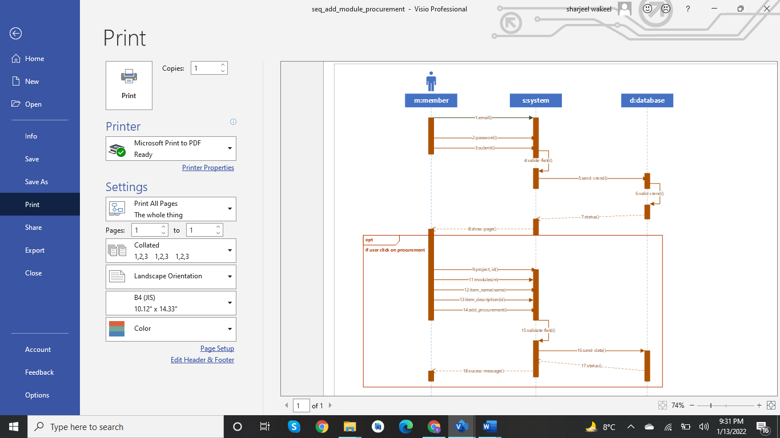

**Fig 5.5: sequence diagram for procurement**

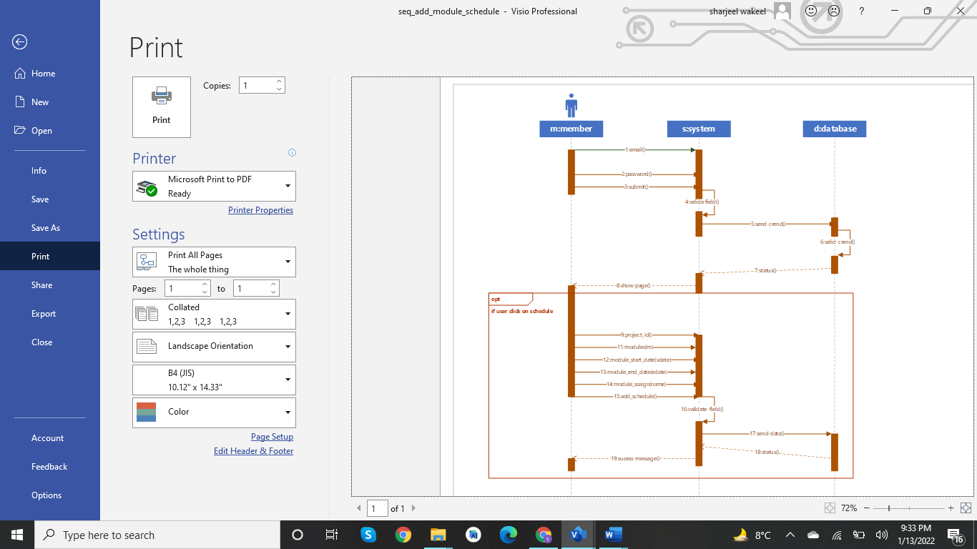

**Fig 5.6: sequence diagram for scheduled**

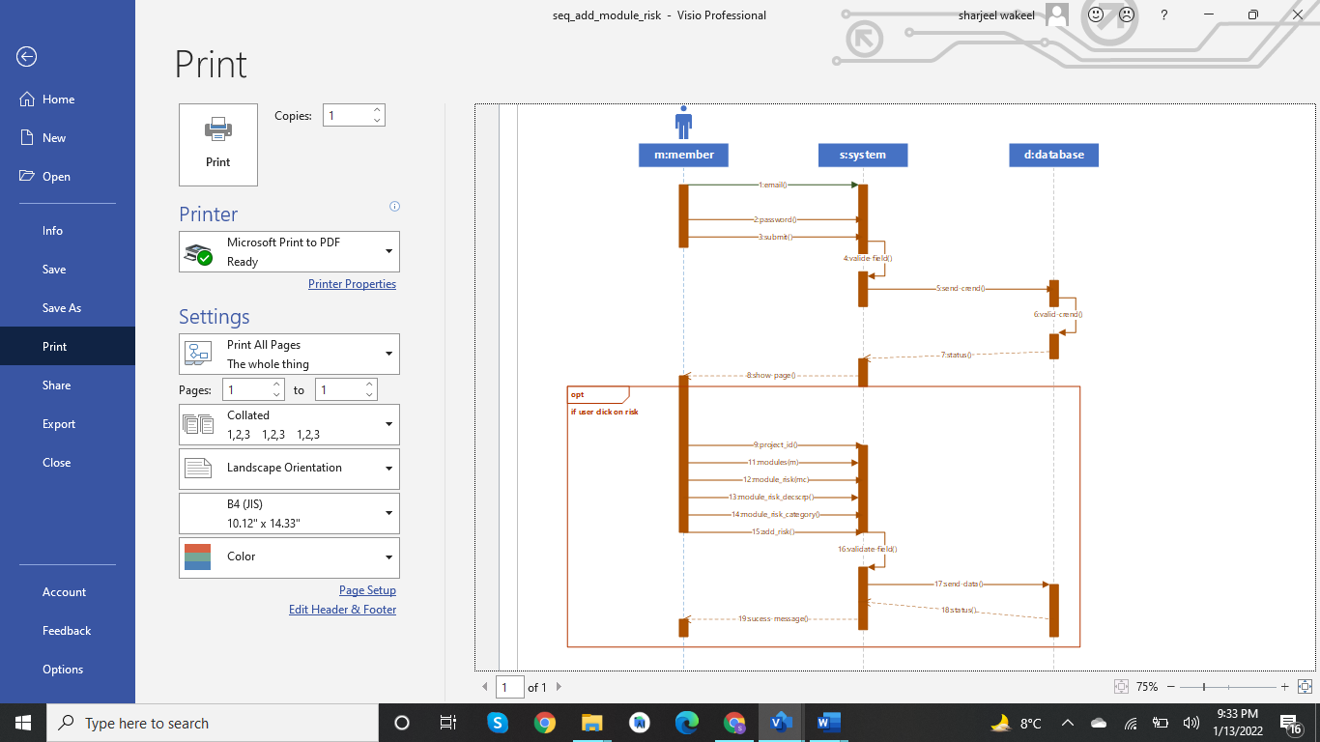

**Fig 5.7: sequence diagram for Risk**

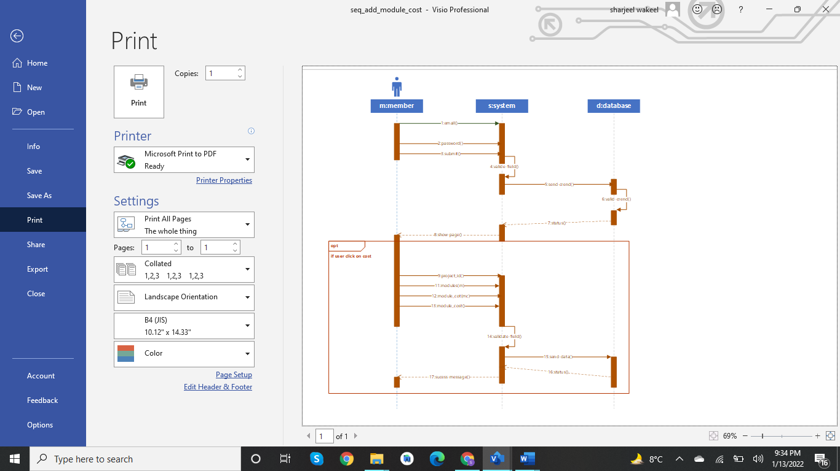

**Fig 5.8: sequence diagram for cost**